1. Download and install InnnoSetup

https://jrsoftware.org/download.php/is.exe

1. Open Butterworth/SampleFiltering.sln and build

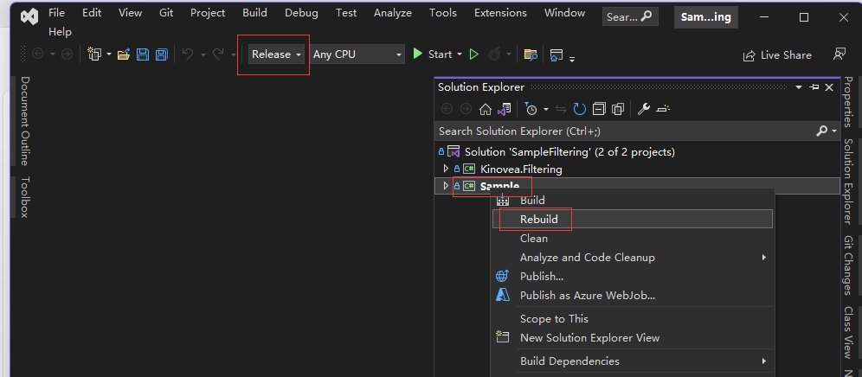

1. Open src/Chronojump.sln and publish

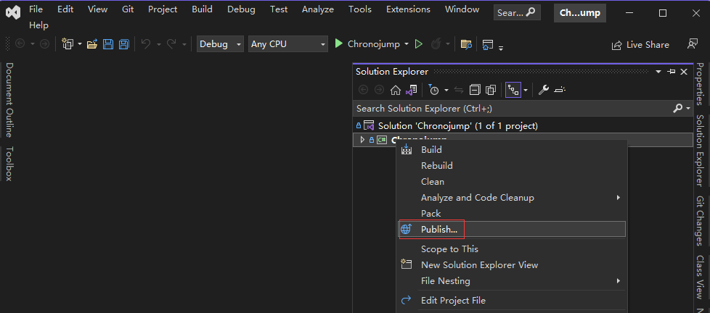

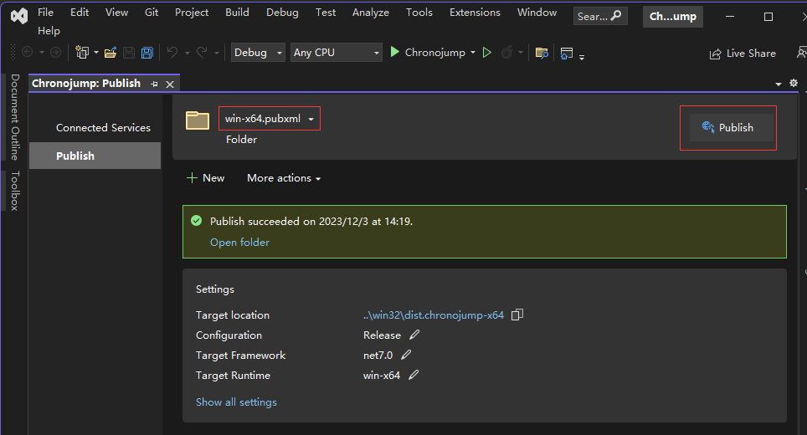

1. Run InnoSetup and choose iss script

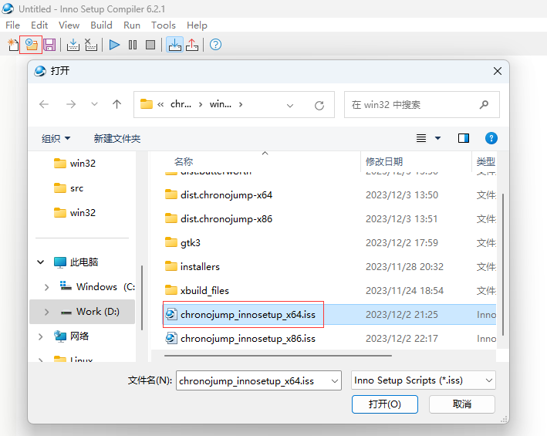

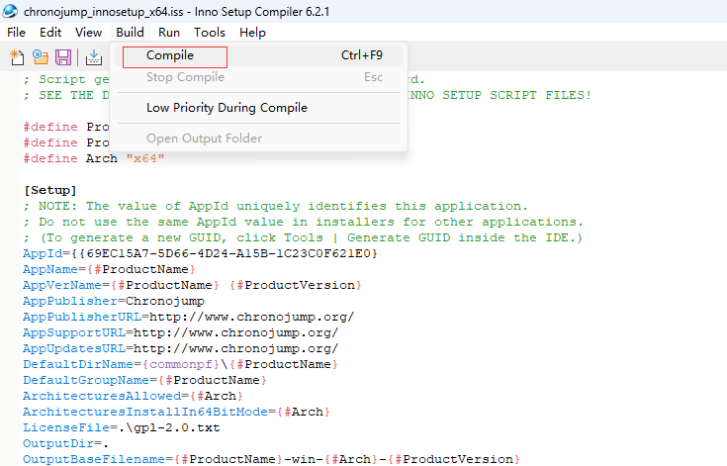

1. The Windows package named “chronojump-win-x64-1.0.exe” locates in folder “win32”